APS-13-06

April 10, 2013

MEMORANDUM FOR HOME AND COMMUNITY SERVICES FIELD STAFF

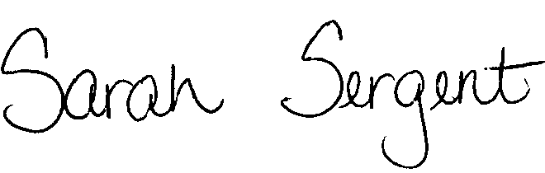
From: Sarah Sergent, Bureau Chief
Bureau of Program Integrity

Subject: Adult Protective Services Manual Revisions

Adult Protective Services (APS) Manual
1703.20 Policy has been revised to provide additional detail and instruction on gathering and documenting evidence during an APS investigation.
1703.20 The Request for Medical Records letter has been added to Policy. The letter also Exhibit D addresses the issue of fees charged by medical providers for medical records.
This memo will be posted on the DHSS Intranet at the following link: http://dhssnet/seniorservices/psmanual/memos.php.
If you have any questions, please contact the Bureau of Program Integrity at programintegrity@health.mo.gov or at 573-526-8557.

The policy revisions are effective upon receipt.

SS/MF/AS

