APS-13-05

February 11, 2013

MEMORANDUM FOR HOME AND COMMUNITY SERVICES FIELD STAFF
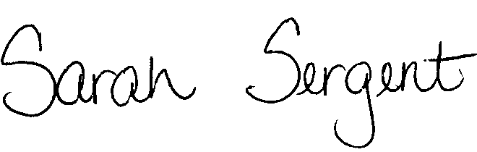

From: Sarah Sergent, Bureau Chief

Division of Senior and Disability Services

Subject: Adult Protective Services Manual Revisions

Adult Protective Services (APS) Manual

1701.30 Removed statute reference regarding in-home provider agency contracts and punitive actions as this no longer is relevant to DSDS.

1702.60 Policy has been revised to update the Class I examples.
Appendix A

This policy is posted on the DHSS Intranet at the following link: http://dhssnet/PSManual/index.html. Staff shall use this memorandum as a guide to view and print the manual revisions.
Questions should be directed to the Bureau of Program Integrity at 573/526-8557 or by e-mail at programintegrity@health.mo.gov.

The policy revisions are effective upon receipt.
SS/MF/LS

