APS-13-04

February 5, 2013

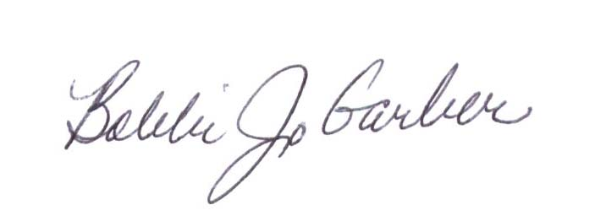
MEMORANDUM FOR HOME AND COMMUNITY SERVICES FIELD STAFF

From: Bobbi Jo Garber, Deputy Director

Division of Senior and Disability Services

Subject: Adult Protective Services Manual Revisions

Adult Protective Services (APS) Manual

1702.00 Policy has been revised to include language on Information Quick Request (IQR) reports and Information Detailed Request (IDR) reports. The policy revision also includes language on field-generated hotline reports.
1702.60 Policy has been revised to include the definition of “serious physical injury,” as it applies to Class I reports, as well as the definition of “serious physical harm” as it applies to Class II reports. Examples of “serious physical harm” have been added. The “re-classifying” of reports language has been removed. Definitions of Class I, II, and III reports have been revised.
1703.40 Policy has been revised to address new timeframe for initiating Class I reports. Any reference to “county” has been removed and the requirements for Class III reports are included. Policy has been revised to include information on requesting a waiver or postponement exception as it applies to required tasks in Case Compass.
1707.77 Policy has been revised to clarify timeframes for sending the Reporter Notification Letter (DA-350).

This information is posted on the DHSS Intranet at the following link: http://dhssnet/PSManual/index.html. Staff shall use this memorandum as a guide to view and print the manual revisions.
Questions should be directed to the Bureau of Program Integrity at 573/526-8557 or by e-mail at programintegrity@health.mo.gov.

The policy revisions are effective upon receipt.
BG/MF/LS/AS

