APS-13-02

October 18, 2012

MEMORANDUM FOR HOME AND COMMUNITY SERVICES FIELD STAFF

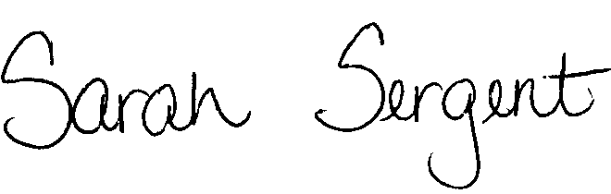
From: Sarah Sergent, Bureau Chief
Bureau of Program Integrity

Subject: Adult Protective Services Manual Revisions

Adult Protective Services (APS) Manual

1704.48 The policy on Guardianship/Conservatorship has been revised as a result of Senate Bill 213 which modifies what information is required when filing a petition for Guardianship or Conservatorship. SB 213 adopts the Uniform Adult Guardianship and Protective Proceedings Act (UAGPPJA) into section 475.501. The policy revisions also include additional direction from the Office of General Counsel regarding filing for Guardianship/Conservatorship.
1704.48 Exhibit B The Guardianship/Conservatorship Identifying Information form has been updated to provide additional information to the Office of General Counsel when a petition for Guardianship/Conservatorship is being filed. This Form may be completed electronically and then submitted to the Office of General Counsel along with 1704.48, Exhibit A.

This information is posted on the DHSS Intranet at the following link: http://dhssnet/PSManual/index.html. Staff shall use this memorandum as a guide to view and print the manual revisions.
Questions should be directed to the Bureau of Program Integrity at 573/526-8557 or by e-mail at programintegrity@health.mo.gov.

The policy revisions are effective upon receipt.

SS/AS

