APS-13-01

September 11, 2012

MEMORANDUM FOR HOME AND COMMUNITY SERVICES FIELD STAFF
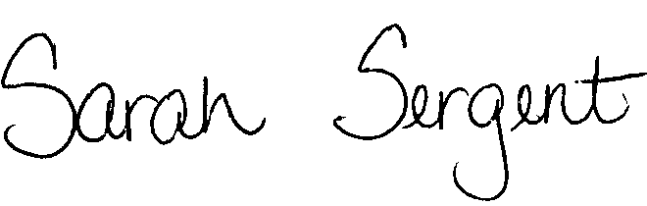

From: Sarah Sergent, Bureau Chief
Bureau of Program Integrity

Subject: Adult Protective Services Manual Revisions

Adult Protective Services (APS) Manual

1701.40 Chapter 565.182 has been revised as a result of Senate Bill 689. The language in elder abuse in the second degree has been clarified for prosecutorial purposes.
1701.70 Chapter 570.145 has been revised to incorporate the use of undue influence in the definition of financial exploitation. The statute updates allow for the release of financial records of Medicaid-eligible nursing facility residents when funds are being diverted from the nursing facility and allows for penalties if this occurs. The revision also provides greater ability to prosecute those who are financially exploiting and are in a position of power over an elderly person or person with a disability.

This information is posted on the DHSS Intranet at the following link: http://dhssnet/PSManual/index.html. Staff shall use this memorandum as a guide to view and print the manual revisions.
Questions should be directed to the Bureau of Program Integrity at 573/526-8557 or by e-mail at programintegrity@health.mo.gov.

The policy revisions are effective upon receipt.

SS/AS

