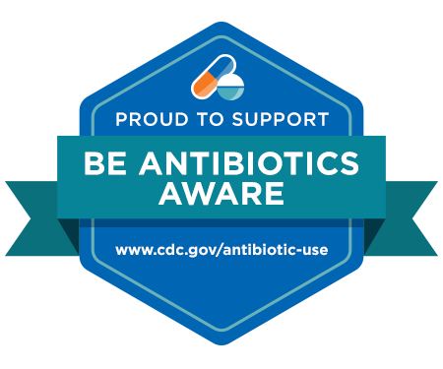

**Respectfully,**

**[Facility Name] Administration**

**[Facility Logo]**

* Sun sensitivities
* *Clostridioides difficile* infections
* Allergic reactions or anaphylaxis
* Nausea or vomiting
* Diarrhea
* Rash or hives
* Antibiotics only treat infections caused by bacteria.
* Antibiotics will **NOT** help you feel better if you have a viral infection, like:
  + A cold
  + Bronchitis
  + Flu or COVID-19
* Antibiotics are one of the major causes of medication related side effects.
* Using antibiotics when they are not needed may cause the bacteria to become resistant to the antibiotic. This will cause the antibiotic to not work that next time that it is needed.

**Our promise to you is that we will treat our residents like we would want to be treated, all while promoting responsible antibiotic use. We are more than happy to answer any questions that you may have about antibiotic use in the treatment of your family member and our residents.**

**Dear Residents and Families,**

We, at **[Facility Name]**, take great pride and investment in the care of all of our residents living here. We are committed to providing our residents with the best possible care. This commitment also includes the responsible use of antibiotics. We would like to provide you with some information regarding the responsible use of antibiotics.

An Important Message From Our Facility’s Administration