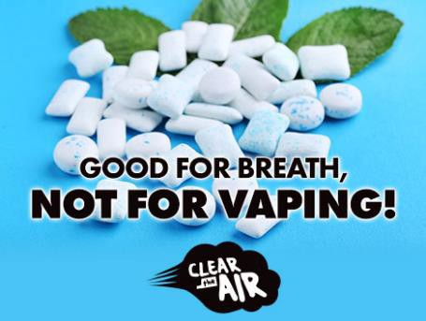
Post Copy:
Your gut can handle a lot more than your lungs and flavorings in e-liquids may not be safe when inhaled. Learn more at stopthevapemissouri.org

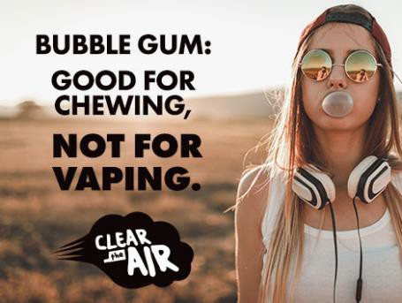
Post Copy:
Flavors lure you - Nicotine hooks you. Most e-cigarettes contain nicotine - the addictive drug in cigarettes, and other tobacco products. Learn more at stopthevapemissouri.org

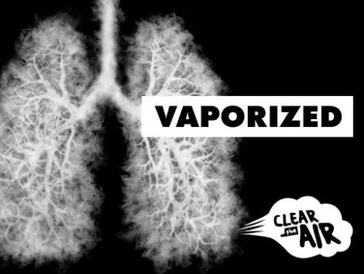
Post Copy:
Besides nicotine, e-liquids can contain cancer- causing chemicals, heavy metals, and ultrafine particles that can be inhaled deeply into the lungs and harm your body. Learn more at stopthevapemissouri.org

Facebook Post Images

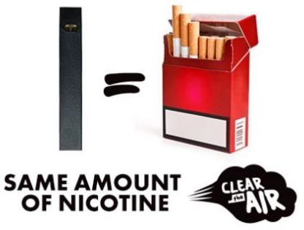Facebook Post Images

Post Copy:
One JUUL pod has the same level of nicotine as a pack of cigarettes. Nicotine can harm parts of the teen brain that control attention and learning. Visit stopthevapemissouri.org to learn more.


Post Copy:
Flavorings, such as diacetyl, used in some buttery flavored e-liquids can lead to a serious lung disease. Learn more at stopthevapemissouri.org

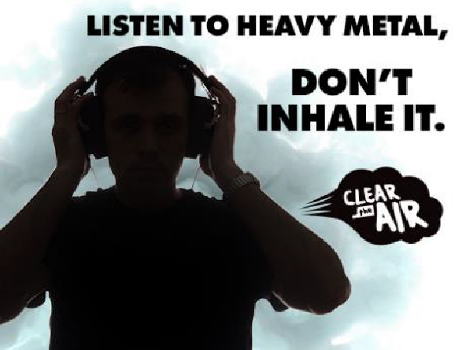Post Copy:
Besides nicotine, e-liquids can contain heavy metals, and ultrafine particles that can be inhaled deeply into the lungs and harm your body. Learn more at stopthevapemissouri.org

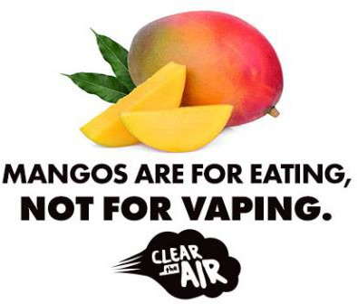Facebook Post Images

Post Copy:
Flavored e-liquids may seem harmless, but don’t be fooled. Most contain nicotine that can prime your brain for addiction to other drugs. Learn more at stopthevapemissouri.org

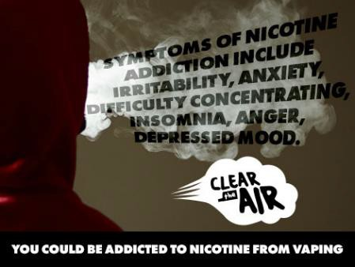
Post Copy:
What is nicotine addiction like? Are you feeling edgy, anxious, restless, angry, can’t sleep? When the nicotine wears off - your brain craves more. The more you vape, the more hooked you become. Visit stopthevapemissouri.org to learn more.

