Missouri’s At-Risk, Afterschool Program

T
he Child and Adult Care Food Program offers funding for snacks and supper meals in organized afterschool programs. The program benefits children by:
- providing needed nutrition and
- helping reduce or prevent children’s involvement in juvenile crime or high-risk behaviors.

Program Eligibility Requirements
To be eligible for reimbursement under the Child and Adult Care Food Program, At-Risk, Afterschool Program must meet the following criteria:

- The afterschool program must be operated by a public or private, not-for- profit organization, or a private, for-profit organization, that has at least 25 percent of enrolled children’s care paid through Title XX funds.

- The purpose of the program must be to provide care in afterschool settings. This does not mean that the program must offer formal, all-day child care (although many
of these programs would be eligible to participate). The program is only available during the regular school year.

- The afterschool program must include education or enrichment activities in an organized, structured and supervised

environment. Extracurricular activities such as the school choir, debate team, drama society, etc., can qualify to participate under this provision only if their basic purpose
is to provide afterschool care. Under no circumstances can athletic teams or
other groups that limit membership based on ability be approved for participation.
The key would be that the sports or other programs are open to all and do not limit membership for reasons other than space, security or licensing requirements.

Site Eligibility Requirements
- Any afterschool program operated by a public or private organization must be
located in a low-income (“at-risk”) area to be eligible for reimbursement for snacks or suppers. To qualify as low income, the site
must be located in an area served by a school where at least 50 percent of the enrolled children are certified as eligible to receive free or reduced-price school lunches.

- The afterschool program must be licensed by the Missouri Department of Health and Senior Services, Section for Child Care Regulation, or be exempt from licensing requirements. Exempt organizations
must submit documentation to show that minimum health and safety standards have been met. At a minimum, documentation must include a fire safety inspection report and a sanitation report.

- Family child care homes do not qualify for the At-Risk, Afterschool Program.

Reimbursement
Afterschool programs may serve and claim reimbursement for one snack and/or one supper, per child, per day. Children are eligible to participate through age 18. If a student’s nineteenth birthday occurs during the school year, reimbursement may be claimed for that child through the remainder of the school year.

For eligible sites, all meals served to school age children attending the At-Risk, Afterschool Program are eligible for reimbursement at the following rates:
Snacks: $0.88 per child Suppers: $3.23 per child

These rates are effective through June 30, 2018.

Times of Operation
This reimbursement is available only to programs that provide care for children after their school day has ended. It does not apply to snacks and suppers served to children before or during the school day.

Afterschool programs may claim reimbursement for snacks and suppers served on weekends, holidays and other vacation periods during the regular school year.

Programs may not claim reimbursement through this provision when school is not in session (i.e., when school is closed for the summer).

If both snack and supper are served, there must be two hours between the end of the snack meal service and the start of the supper meal service.

The intent is to keep any recordkeeping burden to the minimum necessary to ensure that reimbursement is properly paid. At a minimum, afterschool programs participating in the At-Risk, Afterschool Program must maintain the following records:

- Documentation that the program site is located in an area served by a school in which at least 50 percent of the enrolled students are certified eligible for free or reduced-price meals;
- A daily count of the total number of snacks and suppers served to participating children;
- Documentation of individual children’s attendance on a daily basis; and
- Menus and receipts for the purchase of food and supplies for all snacks and suppers served.
If your afterschool program meets eligibility requirements and wishes to participate in the snack and supper program, please contact the Missouri Department of Health and Senior Services, Bureau of Community Food and Nutrition Assistance, at 800-733-6251. An application packet can be found at health.mo.gov/living/wellness/nutrition/ foodprograms/cacfp/index.php.

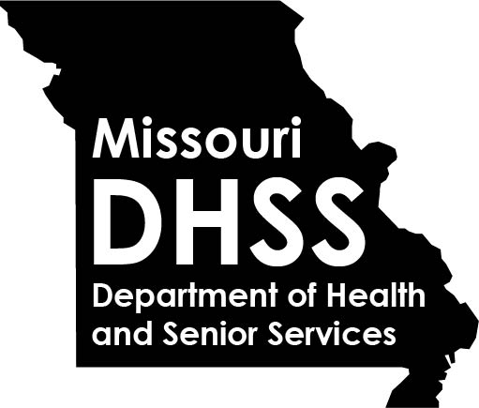
Missouri Department of Health and Senior Services Bureau of Community Food and Nutrition Assistance
P.O. Box 570 Jefferson City, MO 65102
1-800-733-6251

Alternate forms of this publication for persons with disabilities may be obtained by contacting the Missouri Department of Health and Senior Services at 800-733-6251.
Hearing and speech impaired citizen’s telephone
1-800-735-2966. VOICE 1-800-735-2466
AN EQUAL OPPORTUNITY/AFFIRMATIVE ACTION EMPLOYER
Services provided on a nondiscriminatory basis.

In accordance with Federal civil rights law and U.S. Department of Agriculture (USDA) civil rights regulations and policies, the USDA, its Agencies, offices, and employees, and institutions participating in or administering USDA programs are prohibited from discriminating based on race, color, national origin, sex, disability, age, or reprisal or retaliation for prior civil rights activity in any program or activity conducted or funded by USDA.
Persons with disabilities who require alternative means of communication for program information (e.g. Braille, large print, audiotape, American Sign Language, etc.), should contact the Agency (State or local) where they applied for benefits. Individuals who are deaf, hard of hearing or have speech disabilities may contact USDA through the Federal Relay Service at (800) 877-8339. Additionally, program information may be made available in languages other than English.
To file a program complaint of discrimination, complete the USDA Program Discrimination Complaint Form, (AD-3027) found online at: http://www.ascr.usda.gov/complaint_filing_cust.html, and at any USDA office, or write a letter addressed to USDA and provide in the letter all of the information requested in the form. To request a copy of the complaint form, call (866) 632-9992. Submit your completed form or letter to USDA by:
(1) mail: U.S. Department of Agriculture
Office of the Assistant Secretary for Civil Rights
1400 Independence Avenue, SW
Washington, D.C. 20250-9410;
(2) fax: (202) 690-7442; or
(3) email: program.intake@usda.gov.
This institution is an equal opportunity provider.

Missouri’s
At-Risk, Afterschool Program

Healthy eating helps students
make the grade!

Missouri Department of Health and

1/18

Senior Services

