Message Development Worksheet for Emergency Communication

First, consider the following:
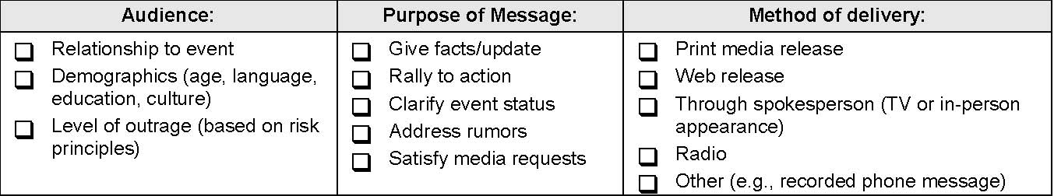

Six Basic Emergency Message Components:
1. Expression of empathy: ____________________________________________________________________________________
____________________________________________________________________________________

2. Clarifying facts/Call for Action:

Who________________________________________________________________________________
What________________________________________________________________________________
Where_______________________________________________________________________________
When_______________________________________________________________________________
Why________________________________________________________________________________
How________________________________________________________________________________
Add information on what residents should do or not do at this time _______________________________
____________________________________________________________________________________

3. What we don’t know: ____________________________________________________________________________________
____________________________________________________________________________________

4. Process to get answers: ____________________________________________________________________________________
____________________________________________________________________________________

5. Statement of commitment: ____________________________________________________________________________________
____________________________________________________________________________________

6. Referrals:
For more information __________________________________________________________________
Next scheduled update__________________________________________________________________
Finally, check your message for the following:
Positive action steps  Honest/open tone  Applied risk communication principles  Test for clarity  Use simple words, short sentences | Avoid jargon  Avoid judgmental phrases  Avoid humor  Avoid extreme speculation

Source: CDC–Crisis and Emergency Risk Communication, CDCynergy

