AGENDA
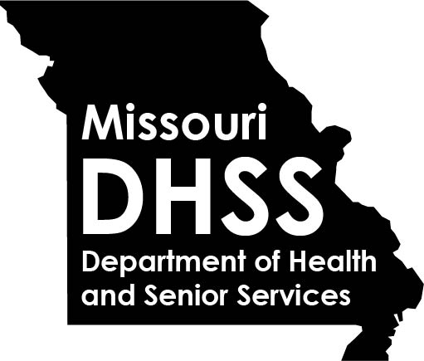

REGIONAL PUBLIC HEALTH MEETING

June 9, 2021
9:00 a.m. – 12:00 p.m.
Virtual via WebEX

9:00 a.m. – 9:15 a.m. | Welcome/OVERVIEW & UPDATES |  | DCPH Leadership
9:15 a.m. – 9:45 a.m. | eletronic health record  Panel Discussion |  | LPHA Panelists
9:45 a.m. – 10:15 a.m. | MoALPHA LEGISLATIVE/MEMBER UPDATES  - 2021 Bill Activity  - LPHA Authority  - LPHA & Legislator Relationship  - Communication |  | Diane Weber, Executive Director  and/or MoALPHA Member Representative  Missouri Association of Local Public Health Agencies  Moalpha2004@yahoo.com
10:15 a.m. – 10:30 a.m.  10:30 a.m. – 11:30 a.m. | Discussion regarding future communication with dhss  Change is Constant: Leading through Change |  | LPHAs and DCPH Staff  John Thomas, Chief People Officer  DHSS, Office of Human Resources  John.Thomas@health.mo.gov
11:30 a.m. – 12:00 p.m. | For the Health of Missouri, Help us Hit all 115! |  | Shirley Farrah, Assistant Dean, MU Nursing Outreach and Teaching,  Professor, MU Sinclair School of Nursing  FarrahS@missouri.edu  Lynelle Phillips, Assistant Professor and Extension Nurse Specialist, Department of Public Health/School of Health Professions MU Extension Service  phillipslm@health.missouri.edu
12:00 p.m. | ADJOURN

