Operationalizing the Box-It-In Strategy:
The Box-It-In Strategy can be effectively used in any congregate living or work setting to address a COVID-19 outbreak and decrease the spread of the virus within each community. This model can effectively be used in settings as diverse as long-term care facilities, food processing plants, university dormitories, jails and schools. More information about the strategy can be found at: https://preventepidemics.org/covid19/resources/box-it-in/
County commissioners and local governments can assist with the implementation of the Box-It-In Strategy in their jurisdictions by supporting congregate living and work settings that experience positive COVID-19 cases by working directly with the local public health agency. Additionally, county commissioners and local governments can consider providing CARES Act funding for:
- Testing (e.g. county contracting directly for laboratory services from providers in county; personal protective equipment for individuals collecting samples; staff time for individuals collecting samples – this might be provided through the local public health agency, federally qualified health center or a hospital for instance; purchasing reagents or other testing supplies for use by providers in county; Abbott ID software for existing machines in county).
- Contact tracing of positive individuals.
- Identification and provision of alternate living situations for individuals who may need to quarantine and cannot return home safely to do so.
- Cleaning/disinfecting of quarantined areas, congregate living and work places.
The following pages provide a high-level overview of the Box-It-In Strategy and additional resources for implementing this strategy in a congregate living or work place setting in your community.

There are four essential elements of the box-it in strategy:
- Testing
- Isolation
- Contact Tracing or “Find”
- Quarantine
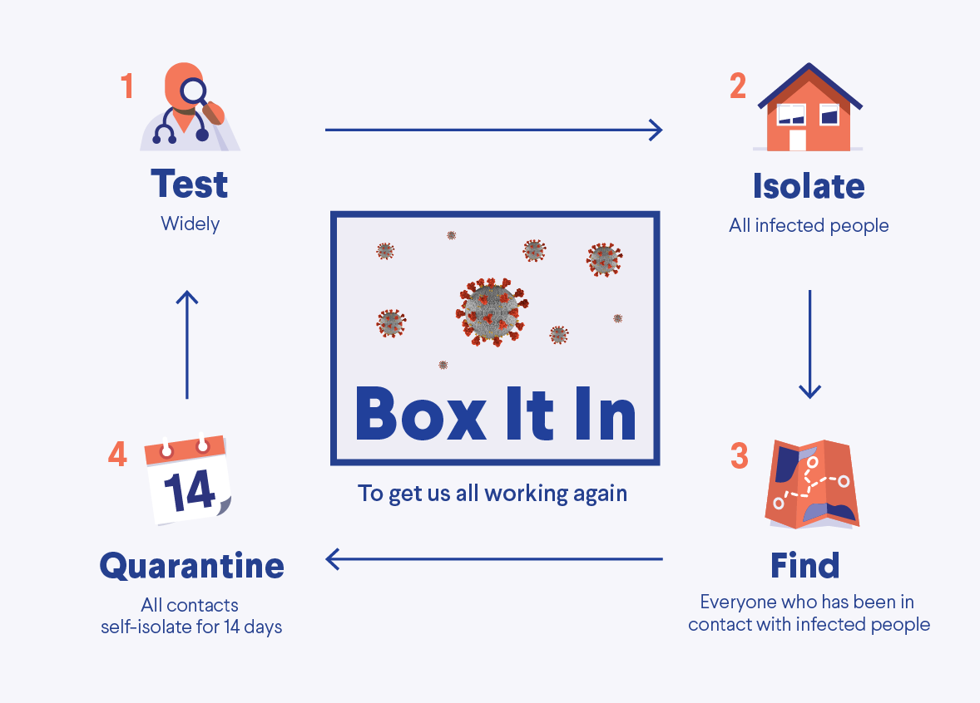

If you become aware that a worker or resident in your work place or facility is positive for COVID, you should immediately contact public health to report the information and seek assistance:
- Assure the positive case is reported, if required. https://health.mo.gov/living/healthcondiseases/communicable/novel-coronavirus/pdf/so-congregate-living-covid-reporting-order.pdf
https://health.mo.gov/living/healthcondiseases/communicable/novel-coronavirus/

- Listing of local public health agencies can be accessed at https://health.mo.gov/living/lpha/.
- Contact the Missouri Department of Health and Senior Services (DHSS) at 1-800-392-0272.
Your local public health department and DHSS will work closely together with you to address the outbreak.

Below are operational steps to assist your facility or work place in implementing the Box-It In strategy:
- Testing
There are several forms of testing available for COVID; which one that should be used can be confusing. For purposes of containing an outbreak at your facility or work place, it is important to use a test form intended for diagnostic purposes. More information can be found at https://www.cdc.gov/coronavirus/2019-ncov/hcp/testing-overview.html

Your local public health agency or local hospital will have information about testing sites in the area. Known testing sites in the state are listed here: https://health.mo.gov/living/healthcondiseases/communicable/novel-coronavirus/mobile-testing.php

You will also need to determine how much of the workforce or living setting needs to be tested. You should consider testing any employee or resident who may have been exposed to COVID, in some instances this may require testing an entire work force or facility. Your local public health agency or DHSS can assist with those determinations.

- Isolate infected individuals to prevent the spread of disease.
Any infected individual should be isolated from the rest of the work force or residents for a minimum of fourteen (14) days from their last known exposure to COVID-19. In some instances, this may mean the infected individuals leave the site, work or live in a separate room or building or in their home.

Your local public health agency or DHSS can assist you in determining the best methods for isolation in your setting.

- Identify contacts with whom the infected individuals may have come in contact.
It is important to identify everyone the infected individual may have come into contact with within a specific timeframe. Please note that this can be an involved process.

Your local public health agency or DHSS can assist in contact tracing infected individuals in your congregate living or work setting.

- Quarantine all identified contacts of the infected individuals.
Individuals who are identified as having contact with an infected individual should self-quarantine in their home, living facility (such as long-term care facility) or another site which decreases their exposure to others for fourteen (14) days.

Your local public health agency or DHSS can assist in answering questions about quarantine.

Thank you for your efforts in your congregate work or living setting to contain COVID-19.

