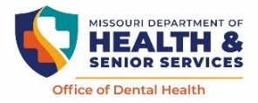**PSP DAY OF EVENT TRACKING FORM**

**Coordinators – SAVE this Tracking Form** to complete the **“Online Mandatory PSP Event Report”** found at [**https://redcapdcphlinux.azurewebsites.net/redcap/surveys/?s=4WMF783KC47W44AC**](https://redcapdcphlinux.azurewebsites.net/redcap/surveys/?s=4WMF783KC47W44AC) following your event.

# **ACCESS TO ONLINE ORAL HEALTH REVIEW FORM**

The individual conductingtheOral Health Reviews today can access the **PSP Online “Oral Health Reviewer Form”** by scanning this QR CODE with their mobile device or go to [**https://redcapdcphlinux.azurewebsites.net/redcap/surveys/?s=93DHXPMT73D8KK7E**](https://redcapdcphlinux.azurewebsites.net/redcap/surveys/?s=93DHXPMT73D8KK7E) and click on tab **PSP Forms, then click “Online Oral Health Review Form”**.

**Wi-Fi password:**

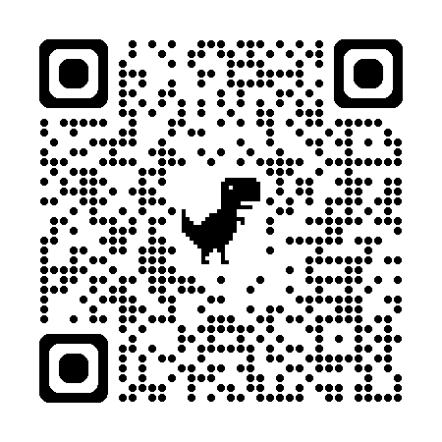

**Volunteer Confidentiality Agreement:** I understand that when I work as a volunteer that any information I read, hear, or learn about a child must remain private. I must obey the HIPAA laws (Health Insurance Portability and Accountability Act). I cannot share any information, including but not limited to student name or type of insurance. I cannot share information about any health problems or treatment needs. I understand that if I fail to keep everything private that I may be asked to leave and/or have possible legal action taken against me for not keeping information private.

**COUNTY:** **______________ SCHOOL NAME: ______________________ DATE: _______­­­_____**

**PLEASE ADD YOUR NAME NEXT TO YOUR PROFESSION / OCCUPATION**

Dentist / Dental Student: ­

Dental Hygienist / Dental Hygiene Student:

Dental Assistant:

Licensed Medical Professional/Med Student:

Other Volunteer:

THANK YOU!

YOU ARE MAKING A DIFFERENCE IN THE ORAL HEALTH OF THE CHILDREN IN YOUR COMMUNITY