Automated Security Access Processing (A.S.A.P)

Requesting access to
Mohsaic Health Management - immunization

__________________________________________________________________

STEP A. Creating A.S.A.P User profile
(This step is to be completed only once per user)

- Open Internet Browser and enter address http://www.dhss.mo.gov/ASAP
- Click the link in the middle of the page that says “To access ASAP”
Click Yes to any security messages
- If this is your first time with A.S.A.P, Choose the NEW USER option

Steps | Screen Print
1. Click the NEW USER option | 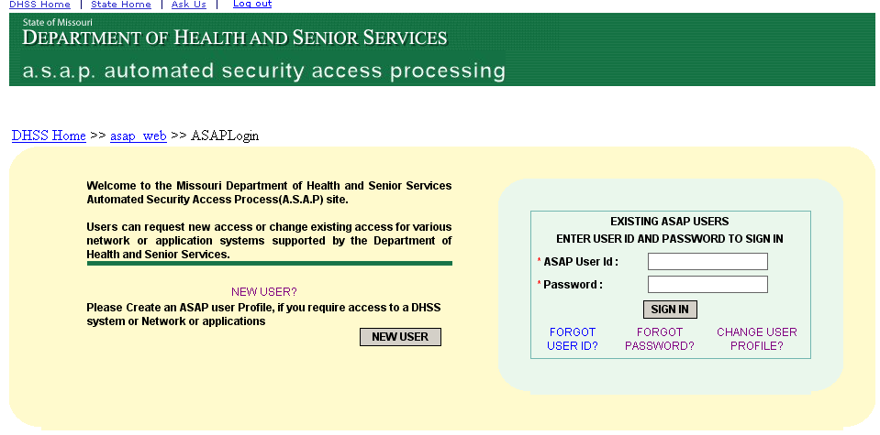
- Enter your first name, last name and last four digits of your SSN.  Enter a Preferred First Name, if desired.  Click the CREATE USERID button. | 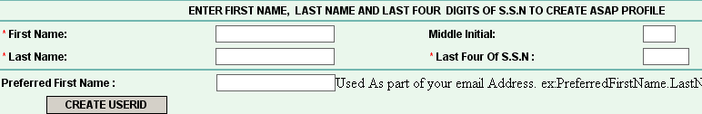
- Make note of your UserID.  Choose ‘Others (Schools, Private Providers, etc.)’ for the Agency. | 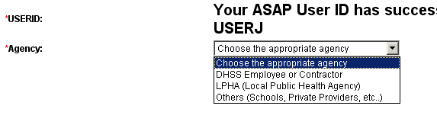
4. Choose ‘DIV OF COMMUNITY & PUBLIC HEALTH DCPH’ for Local Security Officer County. | 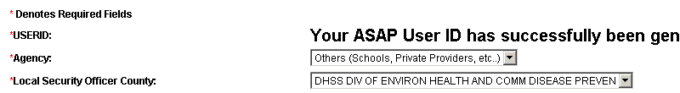
5. Choose ‘IMMUNIZATION LSO (MIKE HUDGENS)’ for Local Security Officer.

6. Type your street number. It will show a drop down list; choose the appropriate Location from the list. | 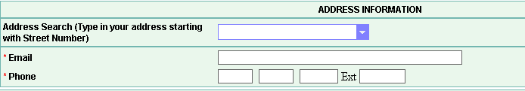
7. Enter your email address
8. Enter your phone number
- Enter your fax number.  10. Enter a password.  11. Retype your password.  12. Enter a challenge question.  (Choose a question for which only you know the answer.)  13. Type the response to the challenge question.  - Retype the challenge response.  - Click CREATE PROFILE.  - You wil get a message stating your profile was created successfully.  - Close out of your Internet browser. | 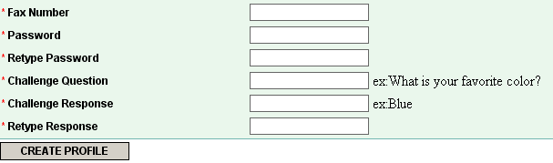

STEP B. Request IMMUNIZATION access

- Open Internet Browser and enter address http://www.dhss.mo.gov/ASAP
- Click the link in the middle of the page that says “To access ASAP”
Click Yes to any security messages

- Type the User ID and Password you created in Step A.  - Click the SIGN IN button. | 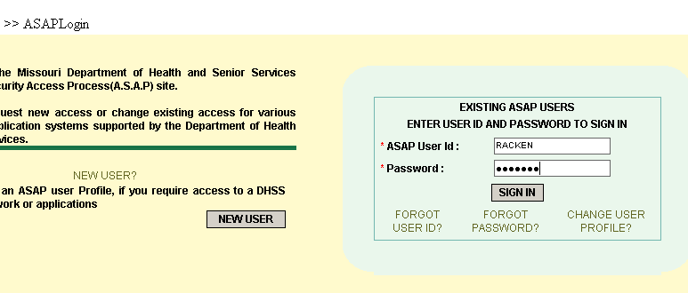
- Choose the ‘Completing for Self’ option.  - Click the NEXT button. | 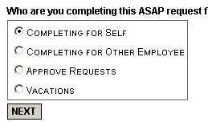
- Choose ‘HEALTH APPLICATIONS’ for Area Type.  - Choose ‘IMMUNIZATION’ for Health Area Type.  - Type your 9 Digit SSN  - Choose ’ADD ACCESS’ for Request Type.  - Choose an appropriate Role.  Note:  Schools usually need ‘SCHOOL REGISTRATION’  Doctor’s offices and clinics usually need ‘ADMINISTRATIVE MANAGEMENT’  - Choose ‘NONE’ for Report type. | 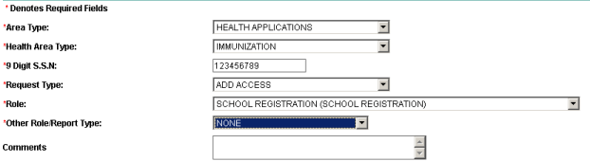
- Optional: If you enter data for more than one facility, click ‘YES’ as the response to the question: “Do you enter data for Additional Agencies?”  11. Choose a county.  - Choose the hospital or ASC for which you will enter data.  - Check the ‘ADD’ box.  - Repeat steps 11 through 13 for additional sites | 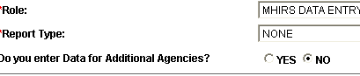
 | 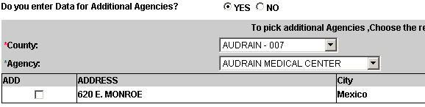
- Click the ‘I Agree’ button.  - Click the ‘Submit Form’ button. | 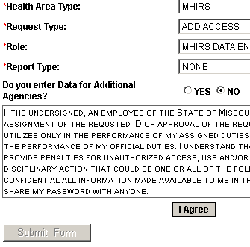
A message should appear stating the request was sucessfully completed.  Print a copy of the form for your records. | 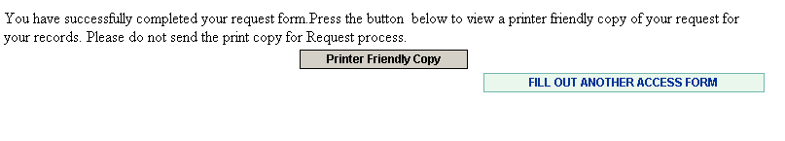

If you experience any problems or have questions while using the ASAP system, please notify the DHSS ITSD Help Desk using one of the following methods:

Phone: 573 / 751-6388 or 1-800-347-0887
E-mail: Support@dhss.mo.gov

