During times of public health crisis, it is sometimes calming to reflect on some of the great strides that have been made in population health in our recent past. Birth MICA is a treasure trove of data, with information spanning nearly 30 years (1990-2018). Let’s celebrate some of the successes we’ve seen in health behaviors and trends of mommas and babies in Missouri.
1. a. How many women reported smoking during pregnancy, statewide, in 1990? 19,540
b. What was the associated rate for this indicator? 24.81 per 100, or 24.81%
c. How many women reporting spoking during pregnancy, statewide, in 2018? 9,913
d. What was the associated rate for the 2018 count? 13.74%
e. Calculate the percent change in overall smoking rates during pregnancy for Missourians during this time interval. -45%;
13.74 (1990) minus 24.81 (2018) = -11.07
-11.07 divided by 24.81 = -0.0446
-0.0446 multiplied by 100 = 44.6%
f. Write a paragraph describing the trends in smoking during pregnancy for Missouri moms.
The decreases in the frequencies and rates of Missouri mothers who report smoking during pregnancy are encouraging. Rates in 2018 are nearly half what they were almost 30 years ago, which is a statistically meaningful decrease (using 95% confidence intervals). These trends support many of the smoking cessation efforts, particularly during the prenatal period, that have taken place in our state over the past decades.
2. a. Which Missouri county had the highest rate of low birth weight babies born in 2017-2018? Dunklin County (12.99 per 100)
b. Which county had the lowest rate? Atchison County (3.26 per 100; rate is unstable)
c. How have the rates for those counties each changed in the past decade?
Though the rates are unstable and rigorous analysis of them is not advised, infants born at low birth weight continues to be a rare event in Atchison County, with fewer than 5 infants born over each two year time period (2017-2018 and 2009-2010).
Dunklin County had a much higher rate of low birth weight births. Over the past ten years, the highest rate of 15.09 (per 100) was logged in 2016. The lowest rate in Dunklin County (9.62 per 100) was in 2010. The fluctuation in rates and lack of a true upward or downward trend is worthy of further analysis to determine which evidence based strategies for decreasing low birth weight would be most advantageous in Dunklin County.
d. Create a data visualization in MOPHIMS that shows geographical, time-sensitive, OR demographic trends related to low birth weight statistics.
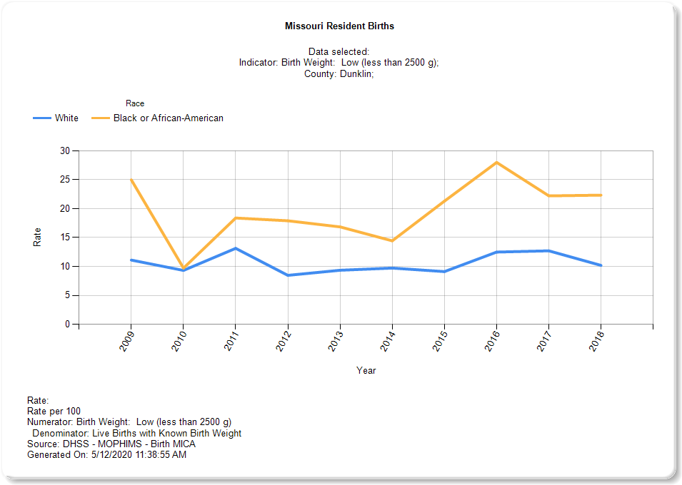
In Dunklin County, low birth weight rates have fluctuated for both White and African-American mothers, though the rate has been consistently higher for mothers who identify as African-American or Black. African-American rates fell consistently from 2011 through 2014 before increasing substantially in 2015. Rates for this demographic group remain higher than the 2010 low. Patterns are largely similar for White residents of the community, though fluctuations have not been quite as severe for this demographic group.

