Speaker 1: Evan Prost PT
Associate Professor University of Missouri, Columbia
Assigned Question:
A. What is Physical therapy?
B. How does it relate to fall prevention?

We call ourselves the Movement Experts.
- Our Job:
  - Identify impairments (musculoskeletal, neurological, cardiovascular, pulmonary) and treat those impairments, across the lifespan.
  - Use plain language to communicate; avoid medical jargon (health literacy).
  - Promote health equity regardless of race, ethnicity, disability, sexual orientation, gender identity, socioeconomic status, geography, preferred language, or other factors.
  - Collaborate as a team with other disciplines!
- Settings: hospital, short & long-term rehab facilities, outpatient, home health, wellness setting
- Business model: hospital system employee, private practice (outpatient), VA, public health
- Payment: Medicare, private insurance, workers comp, Medicaid, CHIP (Children’s Health Insurance Program) First Steps (pre-school), private pay.

(Focusing now on the older adult and fall risk)
Typical 1st encounter for PT is NOT for prevention.
Common 1st encounter for PT is to deal with the consequences of a fall/injury/concussion.

Marketing the Message – Evolution
1990s: instead of selling: “Exercise”, … try selling: “Increasing Your Activity.”
- Why? Most people hate to exercise
(of course traditional exercise is still valuable!)
2000s: instead of selling “Fall Prevention”, … try selling “Stay Independent.”
- Why? Older adults may not want to be labeled or identified as being as a fall risk because of stigma or from the fear of being sent to a nursing home.
  - Denial may be piece of the issue.
  - Lack of awareness or understanding (possible cognitive impairment)
- Framing the message in positive terms is more appealing. It’s a good conversation starter about how to work on the goal of maintaining independence (open-ended questions).

Patient Lesson #1: What makes up Balance?
- Three components: 1) inner ear, 2) vision, 3) the feeling in your feet.
Good conversation-starter when patient/clients understand this principal.

Patient Lesson #2: What will we be doing to improve your balance?
- Wobble! (Clinical definition: the person must train at a safe level that begins to exceed their limit of stability)
- Balance work is a scary process for the patient/client!
  - PT must first develop trust with the patient.
  - PT must keep the patient safe.
  - PT must provide the right amount of intensity. (Goldilocks)
- Research states: 50 hours of balance training is required to begin to reduce fall risk (one hour, twice/week, 6 mo)

Discharge Time from PT … Bridge that Gap!
Our patients deserve more than just a sheet of paper with a home exercise program.

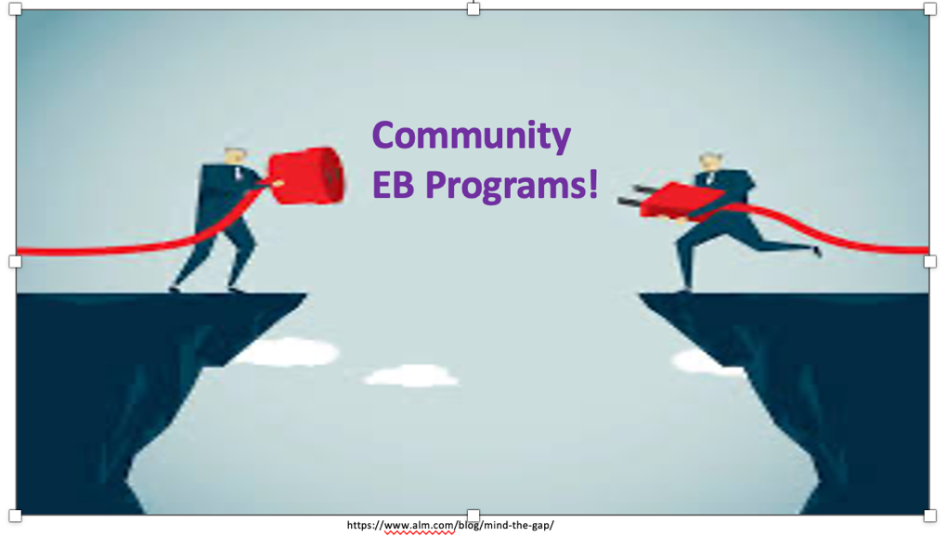

Purpose of Community Evidence-Based (EB) Programs:
- Increasing Physical Activity
- Reducing Fall Risk
- Managing Chronic Conditions

Task for the PT:
- Research your local community wellness practitioners. Area Agency on Aging (AAA) can be a good clearinghouse of info.
- Find programs and find individual trainers that you can trust with a certain category of patients that you are getting ready to discharge.

MU Extension offers EB courses in 119 counties and the city of St. Louis.
EB Courses taught: Stay Strong Stay Healthy, Matter of Balance, Tai Chi, Walk with Ease, Chronic Disease Management for conditions such as diabetes, hypertension, and arthritis.
- In-person classes
- Online classes (!)
- Class fees as low as $50. Some classes are at no cost.

… a parting question …
Evan is curious - How much do the AAA’s and MU Extension talk to each other/coordinate?

https://getyarn.io/yarn-clip/d6adb2fd-048b-4d21-894b-b4b48aa63a85

