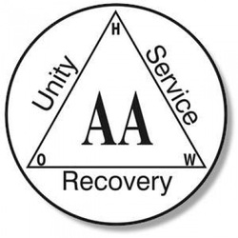
AA: Perryville Alcoholics Anonymous
Time: Every Monday @ 7:30 pm – 8:30 pm
Place: St Vincent DePaul Building
St. Joseph Street, Perryville MO
Contact Info: Chuck D. @573-513-7018

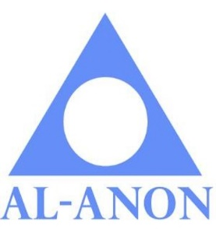
Al-Anon: Perryville Family Support for Alcoholics

Time: Every Other Monday 7:30 pm – 8:30 pm
Place: First Presbyterian Church
6 East Ste Maries, Perryville MO
Come in the back door into fellowship hall
Contact Info: Chuck D. @ 573-513-7018
Celebrate Recovery: Freedom from your hurts, hang ups, and habits
Time: Every Tuesday – Fellowship meal 5:30 pm
Celebrate Recovery 6:15 pm -7:30 pm
Place: First Baptist Church
410 North Main
Contact Info: Church office 547-4644
Women’s AA Group
Time: Every Thursday @ 5:15 pm – 6:15 pm
Place: New Life Mission Inn –Conference room
10 S. Main Street, Perryville MO
Contact Info: Nicole K. @ 573-768-9719

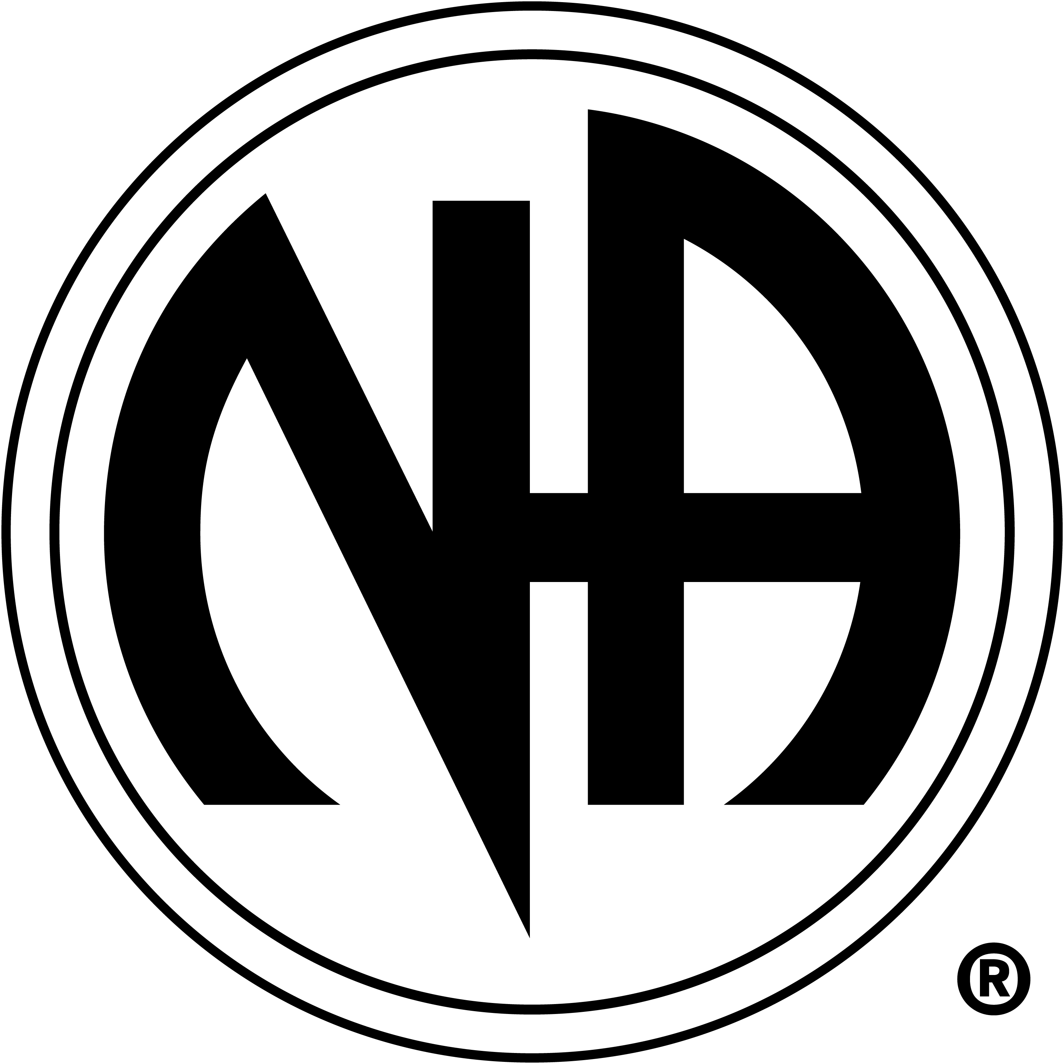
NA: Perryville Narcotics Anonymous

Time: Every Friday @ 5:30 pm – 6:30 pm
Place: First Presbyterian Church
6 East Ste Maries, Perryville MO
Come in the back door into fellowship hall
Contact Info: Chuck D. @ 573-513-7018
Information provided by:
Information provided by: 10 South Main Suite 1 0 South Main Perryville, MO
573-513-2918

