IDENTIFYING THE CRITICAL INFRASTRUCTURE DURING COVID-19 FROM HOMELAND SECURITY
https://www.cisa.gov/identifying-critical-infrastructure-during-covid-19

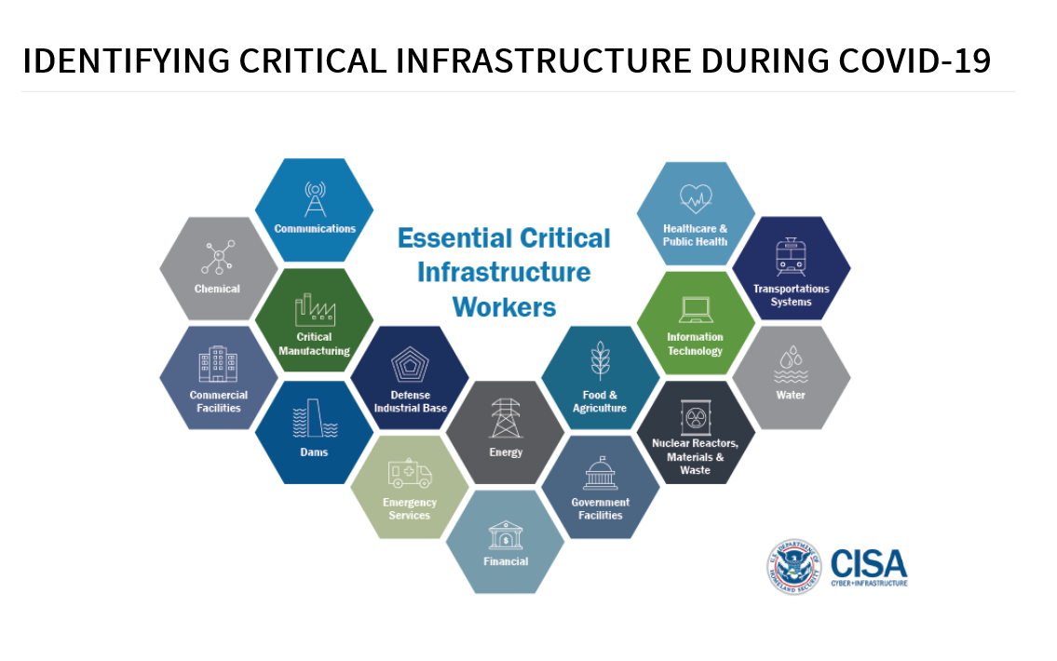

Guidance on the Essential Critical Infrastructure Workforce: Ensuring Community and National Resilience in COVID-19 Response
https://www.cisa.gov/sites/default/files/publications/CISA-Guidance-on-Essential-Critical-Infrastructure-Workers-1-20-508c.pdf

Frequently Asked Questions Regarding Food Service From FDA
https://www.fda.gov/emergency-preparedness-and-response/mcm-issues/coronavirus-disease-2019-covid-19-frequently-asked-questions
