January 28, 2021

To whom this may concern:

This letter is to confirm that all Missouri Area Agencies on Aging, including their subcontractors and staff, are eligible to receive the COVID-19 vaccination under Phase 1B - Tier 1. These agencies serve in the role of providing public health infrastructure and social services first response to the State.

Thank you,

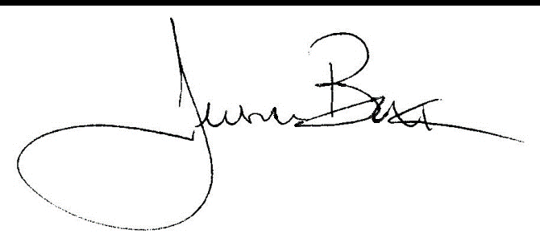

Jessica Bax
Department of Health and Senior Services
Division of Senior and Disability Services

