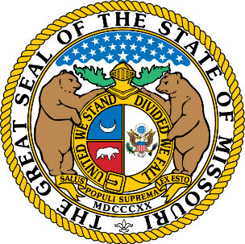

The State of Missouri is grateful to all service members, Veterans, and their families. Words cannot convey Missouri’s appreciation for your dedication and sacrifice. We truly appreciate everything you do for our country and the great state of Missouri.

For your convenience, we have put together a few services and resources available to the military-connected community in Missouri.

Missouri Benefits and Resource Portal
The Missouri Veterans Commission has created a portal to serve as an informational tool and service guide to help service members, Veterans, and their families find benefits and local resources.
www.veteranbenefits.mo.gov
573-522-4061
U.S. Department of Veterans Affairs (VA)
The VA can support you and your loved ones in different ways throughout your life. If eligible, they offer a wide array services like health care, housing, employment, education and more.
www.va.gov
800-698-2411

If you or someone you know is in crisis please call
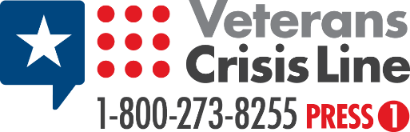
or text 838255

