March 11, 2010

Re: Notice of Lack of Available Funding

Dear Home and Community-Based Services Participant:

Because of the lack of available funding in the current budget of the Department of Health and Senior Services, Division of Senior and Disability Services, your Home and Community-Based services will end April 1, 2010. The Department will no longer pay for your services on or after that date.

If you have any questions concerning this notice, please contact the Home and Community Services Regional Evaluation team for your county of residence. The map on the reverse side of this letter indicates the address and phone number of the team for each county.

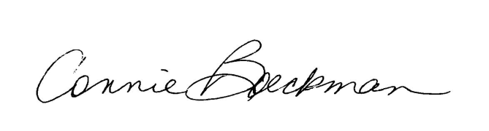
Sincerely,

Connie Boeckman, Interim Director
Division of Senior and Disability Services

