Dear Prospective Summer Food Service Program Applicant:

Enclosed is the application packet for the Summer Food Service Program (SFSP). A copy of our training schedule is also included. Please note that training is mandatory for all sponsors. Experienced sponsors with new staff members should strongly consider sending new personnel to one of the New Sponsor Training sessions for a comprehensive introduction to the SFSP.

Please submit your complete and accurate application by the following deadlines:

- April 1, or the first business day of April, for May commodity delivery
- May 1, or the first business day of May, for June commodity delivery or June advances
- The final deadline is May 15, or 30 days prior to your first day of operation, whichever is earlier.

Completed applications may be mailed to: Missouri Department of Health & Senior Services, Bureau of Community Food and Nutrition Assistance, P.O. Box 570, Jefferson City, MO, 65102, faxed to 1-573-526-3679, or they may be sent by email to sfsp@heatlh.mo.gov.

If there are questions regarding the SFSP application process or other aspects of the program, please call 888-435-1464 or 573-751-6251. Your interest in the SFSP is appreciated and we look forward to the possibility of working with you this summer!

Sincerely,

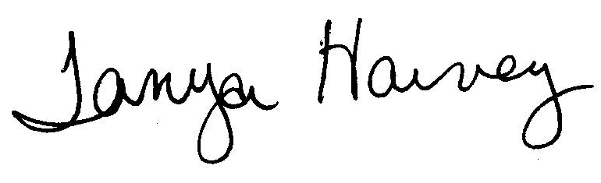

Tanya Harvey, Coordinator of Children’s Programs
Bureau of Community Food and Nutrition Assistance

TH
Enclosures

