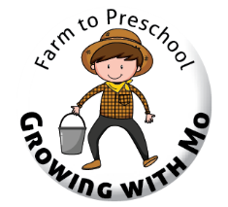
missouri department of health and senior services
Farm to Preschool Project midterm Report

Center or Home Provider Name |  |  |  |  | Report Due Date  6/15/17 |  | Months Covered by Report  March, April, May 2017
Check which fresh fruits and vegetables you used during these months, then the appropriate column for each.
 | Fruit or Vegetable | Locally Grown |  | Grown in your  garden | How did you use the fruit or vegetable?
 |  | Some | None |  | Meal | Snacks |  | Taste testing | Class activity
 | apples
 | asparagus
 | beets
 | blueberries
 | broccoli
 | cabbage
 | cantaloupe
 | carrots
 | cauliflower
 | corn
 | cucumbers
 | grapes
 | green beans
 | kale
 | lettuce
 | okra
 | onions
 | peas
 | peaches
 | pears
 | plums
 | peppers
 | potatoes
 | pumpkin
 | radishes
 | spinach
 | summer squash
 | sweet potatoes
 | strawberries
 | tomatoes
 | watermelon
 | winter squash
 | other -
 | other -
 | other

Describe the farm to preschool project activities you have done. Use extra paper if needed.
Community partnerships: List any organizations or persons who have helped with your farm to preschool project.

Classroom learning experiences: report on curriculum lessons used or created; taste testing; cooking with children; any other learning activities

Field trips taken: List where you went; number of children; what you did

More fruits and vegetables in meals and snacks: Describe how you have increased the fruits and vegetables you offer children in your meals and snacks.

Gardening: Describe any food growing activities, outdoors or indoors.

Family engagement: List handouts or other information given to families, and any ways that families were involved in farm to preschool activities.

