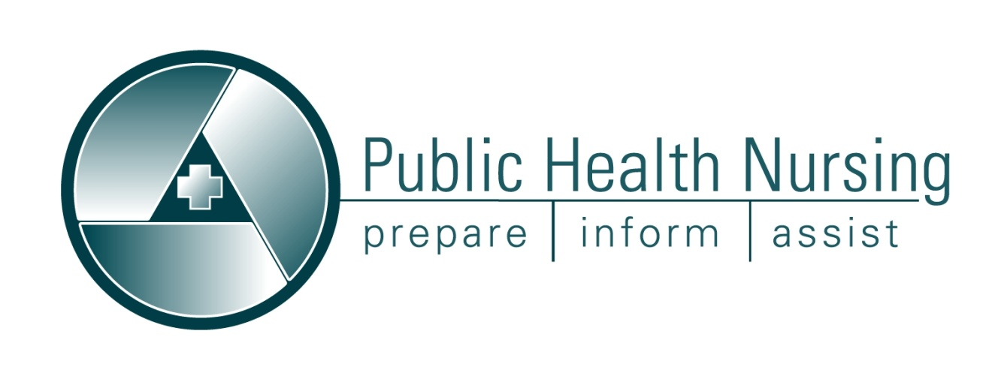
Missouri Public Health Nurses Networking Opportunity!

The Missouri Council for Public Health Nursing (MCPHN) with the Missouri Department of Health and Senior Services (DHSS) invites Missouri public health nurses to join the discussion on the
Missouri Public Health Nursing Discussion Group.

The Public Health Nursing Discussion Group is a way for nurses to:
- Network with other public health nurses in Missouri.
- Receive updates on public health nursing practice issues.
- Seek feedback from your peers on public health nursing issues.
- Discuss current public health nursing topics and share ideas with your peers.

You are invited to join the Missouri Public Health Nursing discussion group (List serve) by subscribing at http://lists.mo.gov/mailman/listinfo/mopublichealthnurse.
*Membership is limited to public health nurses in Missouri.*

For questions or issues, please contact the DHSS Public Health
Nursing Coordinator at (573) 526-0449.

