PrEP Campaign Social Media Assets
Please use the suggested photo/caption pairings when posting assets to social media.

Image | Suggested Caption
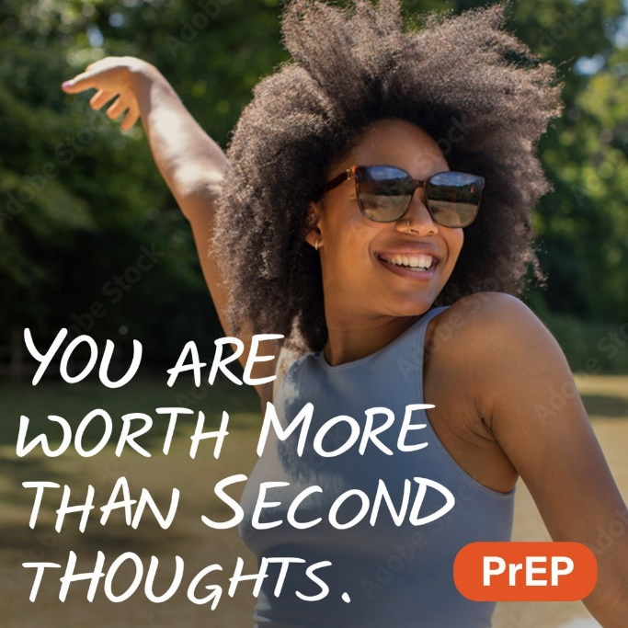 | Never have doubt with PrEP to prevent HIV. It's safe, and it's for everyone. Talk to a healthcare provider today.​
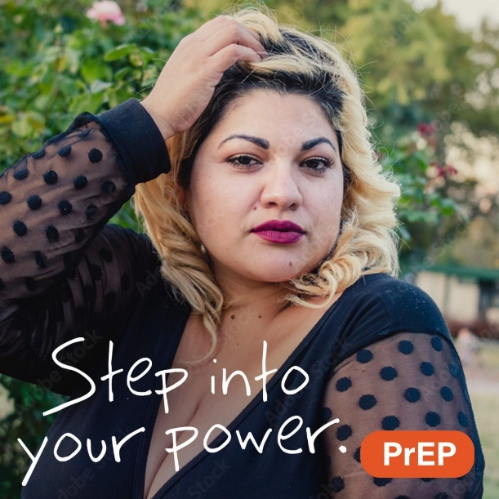 | There's power in protection. Take PrEP to prevent HIV. It's safe, and it's for everyone. Talk to a healthcare provider today.​​
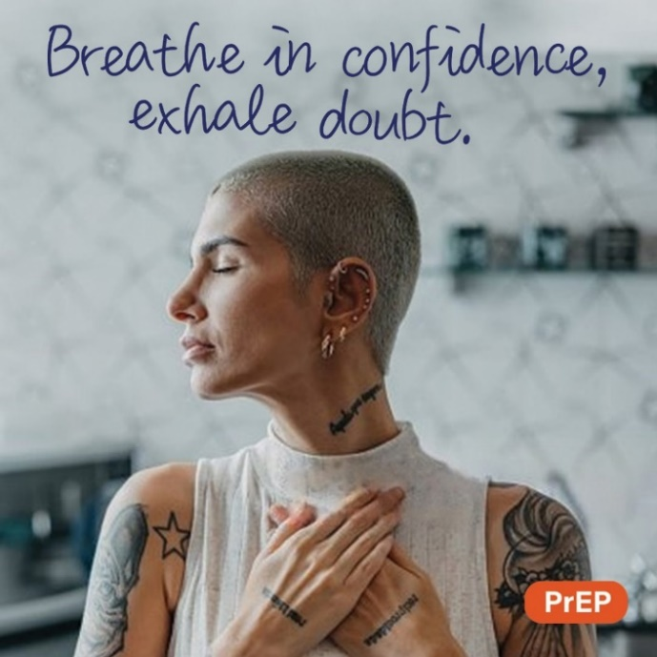 | Be confident. Take PrEP to prevent HIV. It's safe, and it's for everyone. Talk to a healthcare provider today.
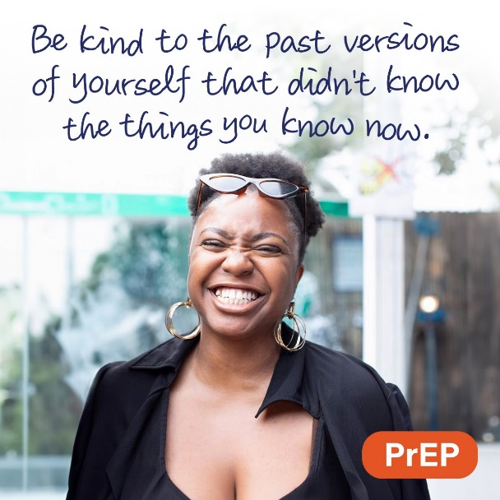 | You are worth loving. And protecting. Take PrEP to prevent HIV. It's safe. It's for everyone. Talk to a healthcare provider today.
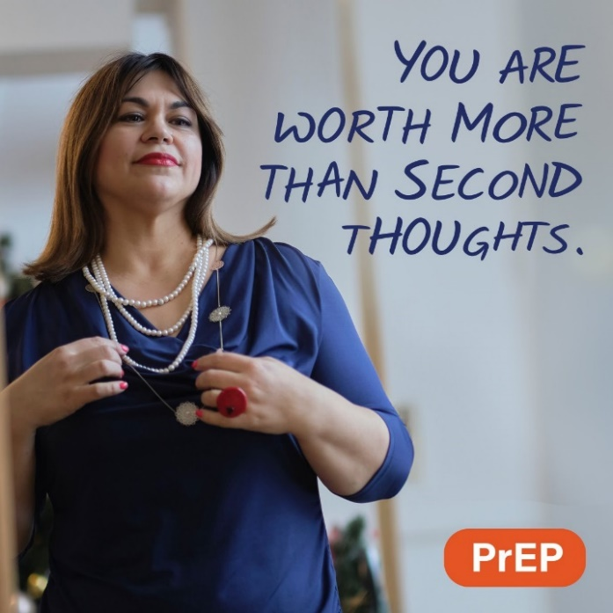 | Never have doubt with PrEP to prevent HIV. It's safe, and it's for everyone. Talk to a healthcare provider today.
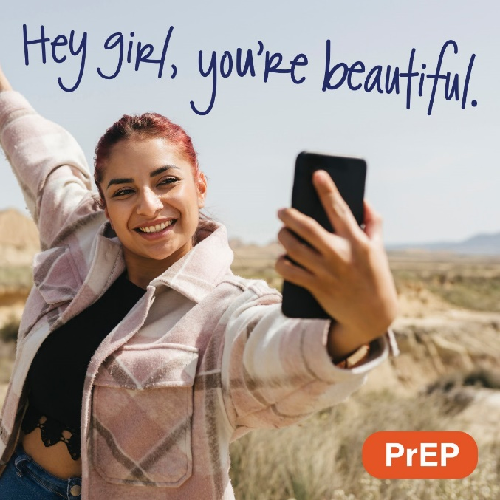 | Show yourself some love. Take PrEP to prevent HIV. It's safe. It's for everyone. And you're worth it. Talk to a healthcare provider today.

Snapchat/Stories

Image | Caption
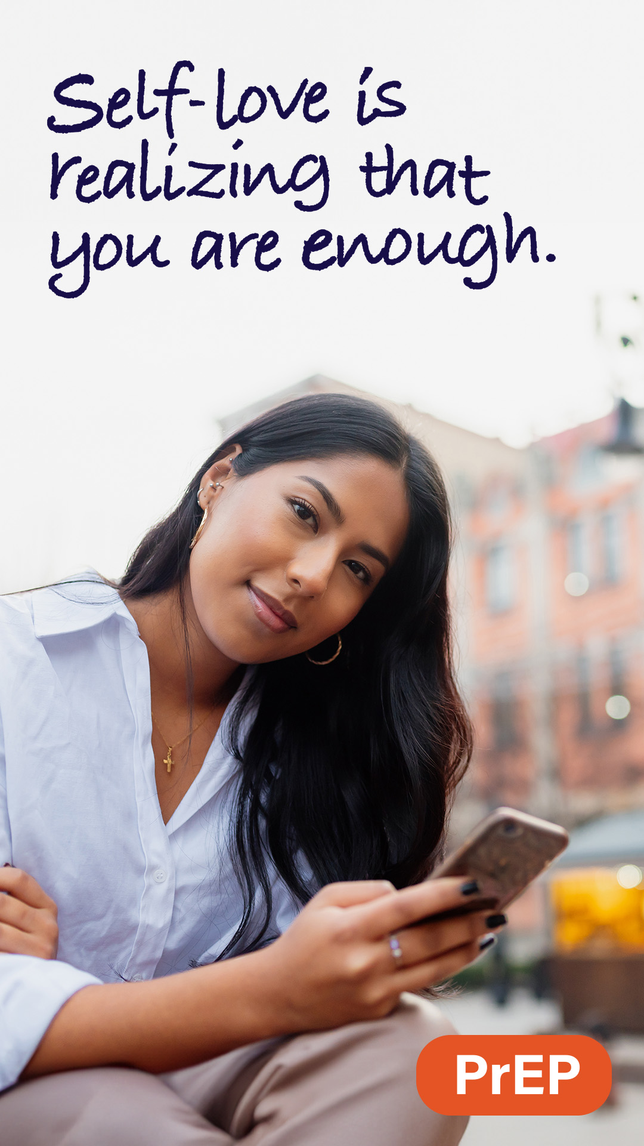 | Show yourself some love. Take PrEP to prevent HIV. It's safe. It’s for everyone. And you’re worth it. Talk to a healthcare provider today.​
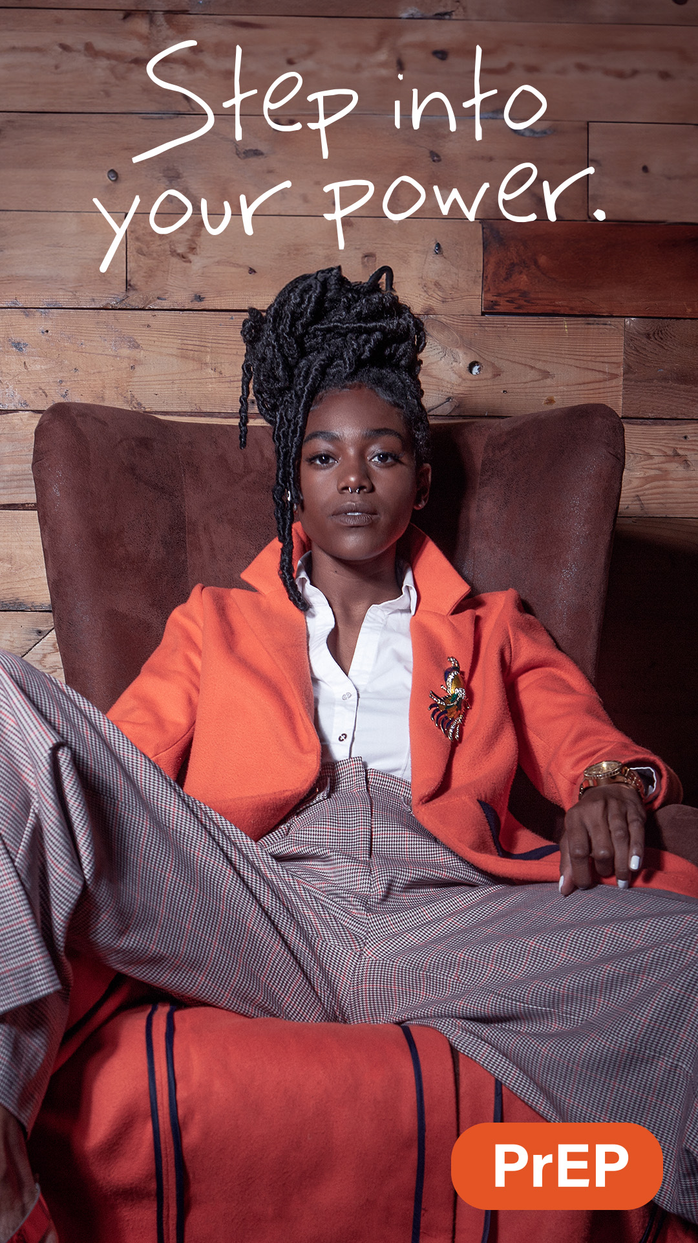 | There's power in protection. Take PrEP to prevent HIV. It's safe, and it's for everyone. Talk to a healthcare provider today.​​

