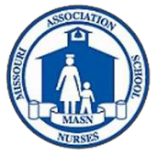
2022 Health Office Orientation
The MO Department of Health and Senior Services (DHSS), School Health Program is partnering with the Missouri Association of School Nurses (MASN) and Missouri Association of Rural Education (MARE) to offer an orientation for health office staff.
Date and Location: July 19-20 at the Governor’s Office Building located at 200 Madison Street, Jefferson City, MO. The meeting will be held in room #450 beginning at 10:00 a.m. on Tuesday, July 19th^{d} and ending at 3:00 p.m. on July 20th.

Purpose: This two-day workshop offers an orientation for nurses without prior work experience in schools and an overview of information regarding school nursing practice.

Areas to be addressed include: general school nurse responsibilities, immunizations, communicable diseases, documentation, chronic disease management, medication administration training and screenings- vision, hearing, dental; as well as review of practices in Special Education Services; Family Educational Rights and Privacy Act (FERPA), and child abuse reporting.

Who should attend: Registered Nurses and Licensed Practical Nurses who have not previously worked in schools, and new heath office staff in schools, working without the benefit of a MD or RN supervisor. Attendance seating is limited and priority registration will be given to those with less than two years of experience in schools and those who have not previously attended the orientation.

Cost: No cost for registration. There is $30 fee payable to MASN for working lunches (2 days). There is also a daily fee for the parking garage of $6.

Registration: https://missouriwic.iad1.qualtrics.com/jfe/form/SV_brewkB4gHOScyWi  ➔ Deadline for Registration is July 7, 2022

Following registration, participants will receive a confirmation email with a list of materials to be completed prior to attending the workshop. (Please note: The emails are sent manually, so allow a day or so for confirmation to be returned.) Lodging options and parking information will be available.

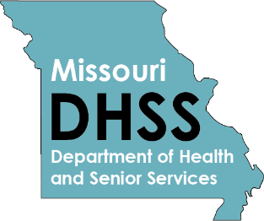
For additional workshop information call the Missouri Department of Health and Senior Services at (573) 522-2822 or email: SHS@health.mo.gov

