National Rural Health Day
PCMH Clinics will be celebrating all week!
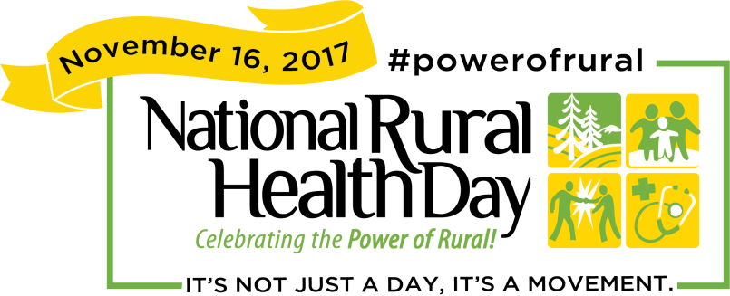
Patient giveaways all week long!
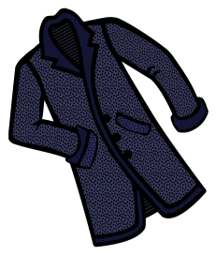
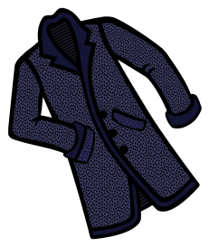
We will be collecting coats for those in need,
drop off boxes located in each clinic.

Sharing cookies with others.
A fabulous turkey dinner with all the trimmings will be offered to all PCMH employees on Thursday, November 16th, beginning at 11am in the 1st floor conference room.
