Practice Exercises.
Earlier in the Newsletter we walked through how to collect data on various causes of death in Missouri. In that example we focused on Cole County. The following three questions will ask you to generate your own, region specific query within the Chronic Death MICA and will increase in difficulty as the questions progress.
Q1: Create a query like the one described in the first article, but choose the County/Counties of your choice. Years = 2007,2017. Geography = Your Choice. Age = Basic. Sex = All. Race = Basic. Cause = Cancer, Heart disease, and Chronic Obstructive Pulmonary Disease. How did your region compare to trends found at the state level (page X).
Solution uses Callaway County as the example.
The rate of Callaway County residents dying due to chronic heart disease has decreased by more than 30% during the time period studied, compared to only a 4% decrease statewide during that same time period. Conversely, the death rate due to cancer in the county has increased from 156.95 (per 100,000) to 185.91, which is a trend inverse to the statewide decrease from a mortality rate of 190.47 (per 100,000) to 167.23. The number of COPD deaths from Callaway County has remained stagnant during the 2007-2017 time period, though the rate has decreased by 21%.
Q2: Create a chart showing the difference between 2007 and 2017 death rate causes.
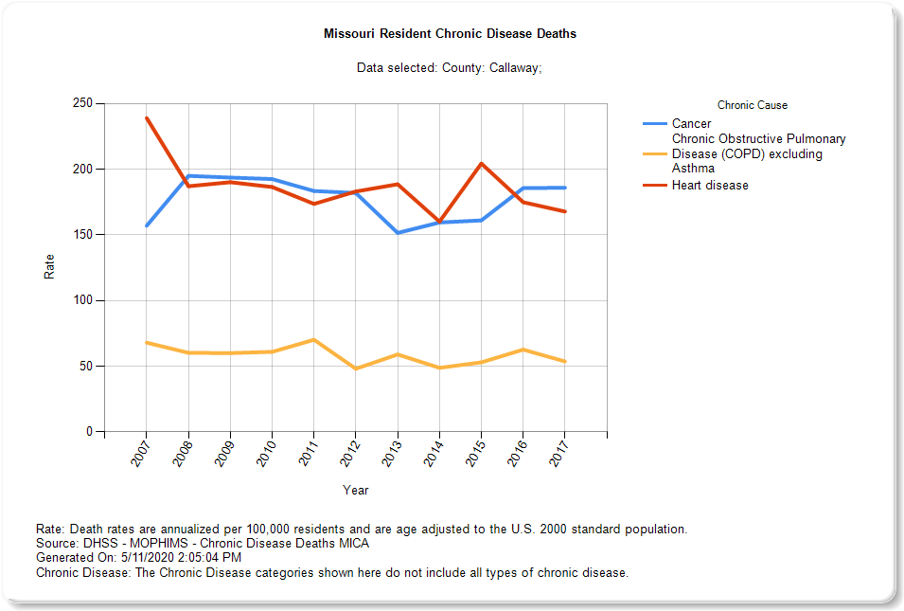
Q3: Using a 95% confidence interval, determine if there is a significant difference between your regions 2007 and 2017 death rates.
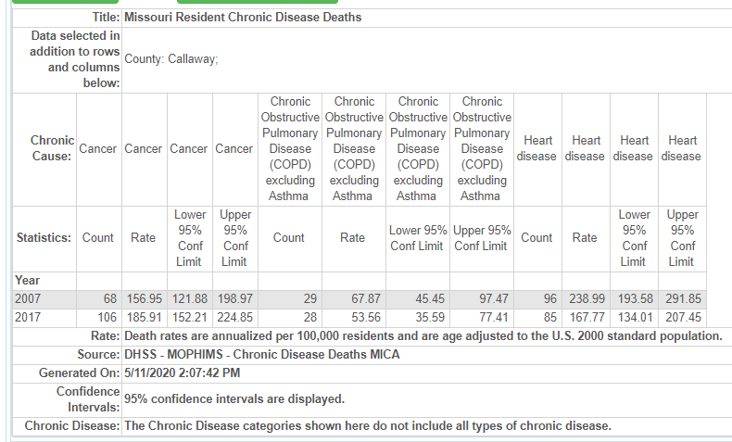
Based on the table created above, there were no significant changes in the rates of chronic death in for the causes studied in Callaway County between 2007 and 2017. Though the rate of cancer mortality increased, the rate was not meaningful when calculated at 95% confidence intervals.

